活動行銷之一二

https://www.facebook.com/mei.chiu.56/posts/9333311976788302

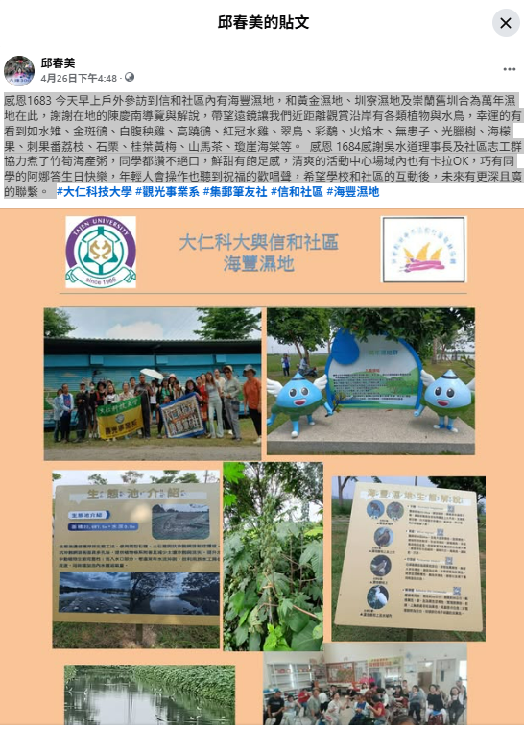

https://www.facebook.com/mei.chiu.56/posts/9369311116521721

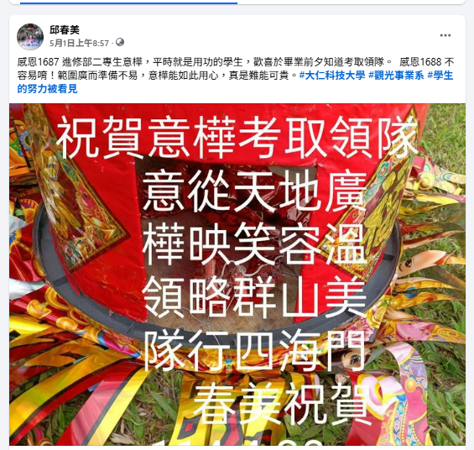

報導學生之一
https://www.facebook.com/mei.chiu.56/posts/9355557891230377
